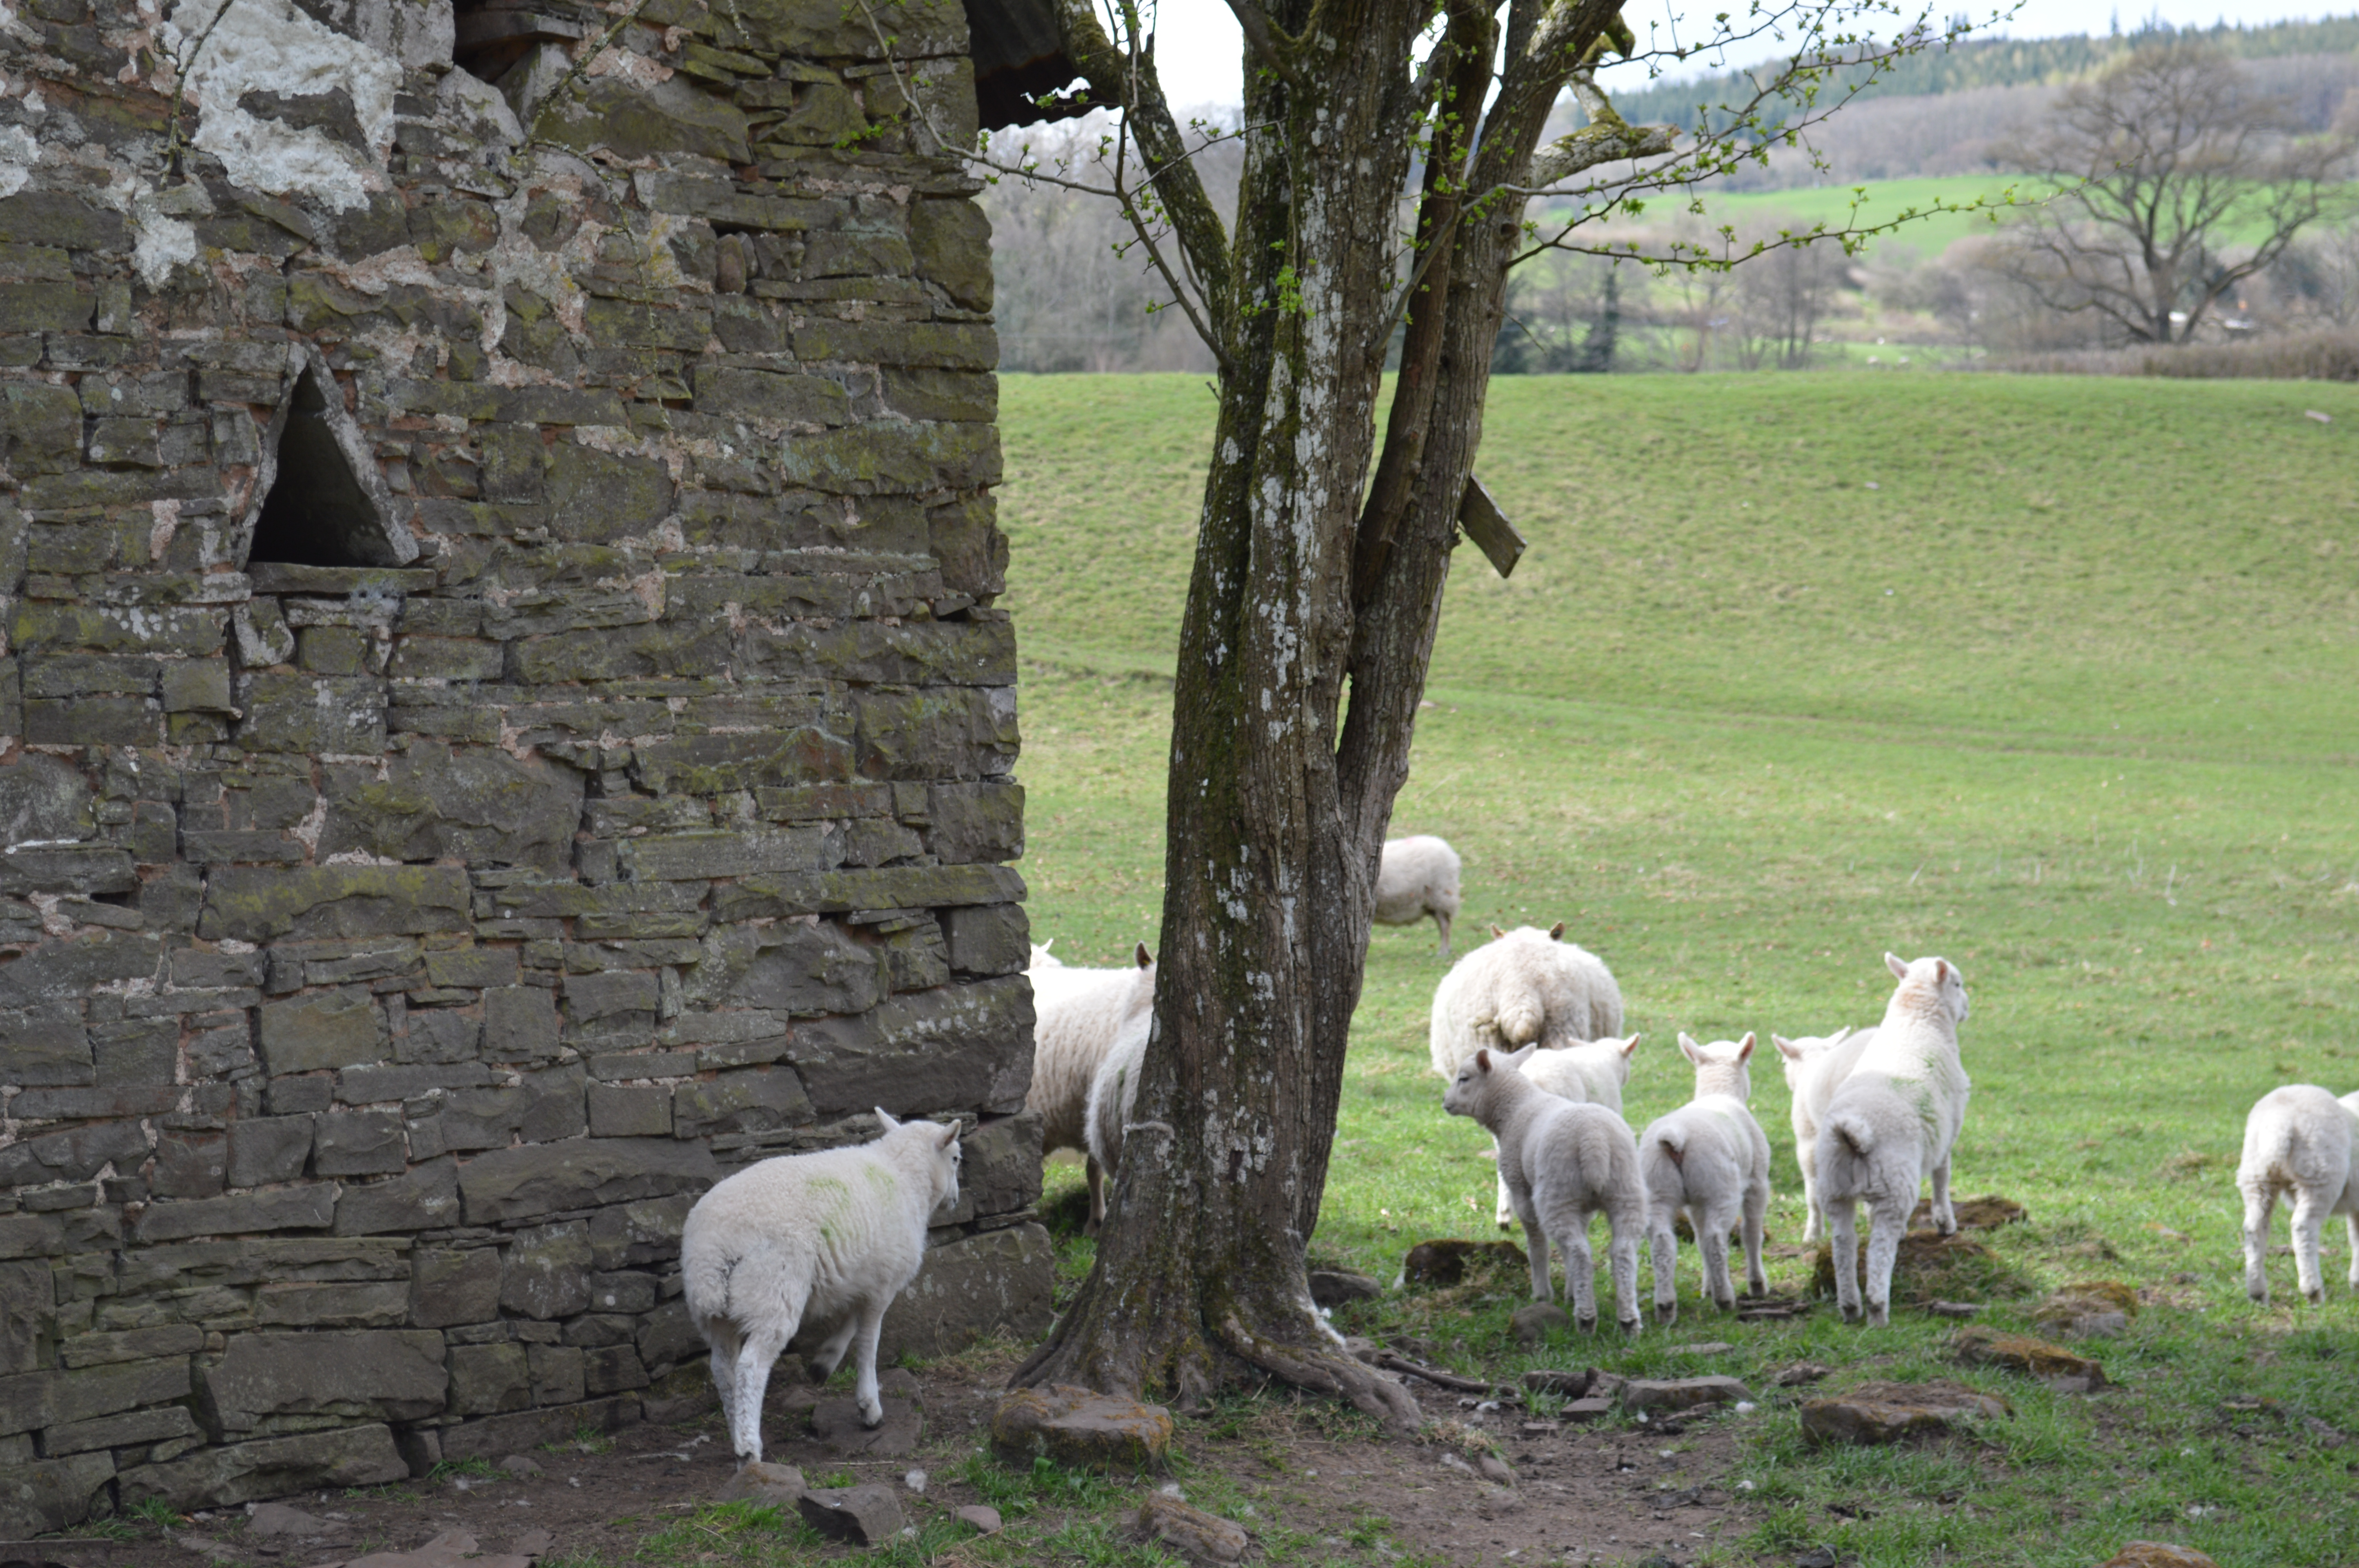

The Trapped Lamb: Thoughts on Ecodharma

(reproduced with the kind permission of Indra's Net,
the journal of the former Network for Engaged Buddhists, first published in July 2012).

My recurring thoughts about ecodharma begin on retreat in the Brecon Beacons. One evening I'm wandering back to my camper van after an evening of peaceful, yet stirring devotional practice on spiritual surrender. It's a damp, dreich night and I'm looking forward to snuggling up with my hot water bottle.

I hear mournful bleating followed by the cry of a young lamb. My heart sinks. I notice fleeting resistance followed by a sense of urgency to find the lamb, who's clearly in some distress. I eventually find him trapped in the boundary fence, tightly-wedged between an old five-bar gate and a new, tightly-wired fence, dangerously close to rusty barbed wire and twisty tangled bramble. As soon as he sees me the lamb freaks out; frightened and struggling, head-butting the fence so his nose bleeds, his near hind leg jammed awkwardly over a rung of the gate.

Once we've had a talk, stroke and snuzzle he softens, calms and drops to his knees. Several failed rescue attempts follow. The lamb's too heavy to lift with one hand whilst lifting the barbed wire with another and pulling him from the other side of the fence won't work. Having recently witnessed a fox tucking into a newly-killed lamb I can't face leaving the lamb to this fate, especially not trapped, without even a fair chance of running back to the protection of his bleating mother and flock. It's dark, cold, I'm scratched, bleeding, smelling of sheep poo and the house is in darkness; my fellow retreatants have gone to bed.

Long story short, I wake up a friend (in fact, the bodhisattva of lambs herself - she used to live at this retreat centre and is very well-versed in lamb rescue and lamb talk. I couldn't ask for better company) and after a bit of yanking, cajoling and comforting the lamb is freed and fine.

I lie in bed recollecting the themes of the night: surrender, fear, vulnerability and friendship. I call upon the bodhisattva Red Tara; her ruby red form and her rite of fascination embodying her desire; desire in its most exalted form - the desire for the liberation all beings. The desire for the liberation of all beings. The next morning in meditation I feel an upsurging and transformation of desire through contemplating the form and actions of Red Tara, as if for the first time. Something gives and shifts into gear. Had I not met the lamb, Red Tara and I wouldn't have met in this way in morning meditation.

The desire for the liberating of all beings is my gateway into Ecodharma. That desire and longing has always been there, before I had the words or knew of Buddhism or Ecodharma. Whilst my idealism might have waned with the years, that desire has strengthened and seasoned. My desire to understand: to understand suffering, my terror of suffering, desire, the transformation of desire, and through understanding all of that more clearly, seeing afresh the human predicament. My desire to relate to others - versus a desire to sometimes run a mile, if I'm honest! - and my desire to figure out whether to respond, how to respond, when to respond and the fear and regret of not responding; shrinking from the cries of the world (and my own cries). The polarities of being and doing, taking action and reflecting, attracting and repelling, accepting and protesting - to name but a few.

I'm excited by the movement encompassed by 'Ecodharma', precisely because it doesn't fit into a category. I love that Ecodharma defies neat pigeon-holing in a mainstream world in which we are obsessed by regulation, standards, competencies, tick boxes and having to know the answer without looking at the web of mutual causality. Brainwashed by reality TV and celebrity culture we continue to ignore (at our peril) the pressing need to really listen and heal wounds - mine, yours, wounds between individuals, in families, in tribes, between nation states, multinationals and indigenous people - well, everyone's' wounds. Not to mention the vast human grief - conscious and unconscious - in facing how we've used and abused the planet and our fellow species for our own ends in our anthropocenic delusion.

Ecodharma matters because of its areas of concern and because it draws in beings from different backgrounds, with a range of expertise, knowledge and experience: ecologists, anthropologists, therapists, community workers, gardeners, political activists, educators, seasoned Dharma practitioners who long to know how to engage with global struggles, and many others. It goes to a further shore than some - not all - of the ecopsychology work of which I am glad to be a part. And it 'talks' to those - some of whom arrive in my therapy room, with very little or no technical knowledge of ecology and Dharma - who know that something just doesn't feel right in the times we're in, and it isn't just to do with their pasts. We find our own way into Ecodharma and our own expression of it. Yet we can only do this in the company of friends and community; seeking to free ourselves from greed, hatred and unawareness so we can liberate ourselves, all sentient beings and in so doing, re-discover our finely-tuned relationship to other life on earth.

Ecodharma matters because it doesn't offer the quick fixes so beloved of our mainstream culture. Instead it offers the path of ethics, meditation and wisdom, aided by the tools of the four sublime abodes of metta, compassion, gladness and equanimity, flying towards the freedom of embodying the impermanent, insubstantial and ever-changing nature of all phenomena. It takes us beyond our anthropocentric gaze so we see that as a species we face challenges that go beyond single causes simply concerning human life. The challenges now aren't solely about the environment or about poverty-alleviation or about biodiversity. They're about all of the 'big' issues, their interrelationship and our dawning recognition of how our historical and recent ways of life - fast accelerated by capitalism - have further alienated us humans, particularly in the Global North. How we've collectively cut ourselves off from our more earth-touching nature and our innate knowledge that we, too, are creatures made of the same stuff we see mirrored in the world around us: earth, water, fire, air, space, consciousness. Whilst societally we are still largely defined and confined by being priced and prized according to our wealth, status, class, caste, appearance, ethnicity, sexuality, culture and gender.

After a youth and younger life of thinking that sorting out the world's problem was about being 'out there' I've realised that it's also about starting from where I am, whilst still looking to the far horizon and taking risks in engaging with myself, others and causes that matter. I was privileged to be an overseas development worker in sub-Saharan Africa for many years. I loved - and was stretched - by the work, interpersonally, culturally and physically (dust-matted hair and an achy bum from hours travelling in rickety trucks on murram roads). Events of my 30s called me to find out 'who's at home' in my embodied experience. This was partly prompted by grief; a plummeting into my depths and digging deeper in going for refuge, fuelled by doubt and faith, and partly prompted by training for ordination, being ordained and starting work as a counsellor and therapist.

Now I find myself in the midst of a return journey, picking up the threads so important to me from sustainable development and therapy work and seeing them through the eyes of a going for refuge being. I was delighted when an ecologist friend pointed out that 'eco' in Late Latin means home or household. This made a lot of sense to me in terms of how I have been drawn to uncover my hearth-dwelling facets in parallel with my more outgoing huntress and lover myths in sustaining my life, work and practice. Hestia meets Artemis and Aphrodites. Personally I have become more rooted, more at home, through researching and knowing more intimately my ancestral lineage and physical place on earth; spaghetti-like cultural threads. I have explored and continue to reflect in more depth on my karmic and samskaric lineage through my practice, therapy work and in particular of late, through writing about embodiment and meditation (and as a result, feeling more at home in my own skin).

I have re-kindled a sense of kinship with other life forms. This realm was so familiar to me as a child (second nature, excusing the unintended pun), and I'm glad to now work with clients outdoors precisely because of the importance of this wider reconnection - healing splits - beyond the sometimes narrow confines of the therapy room. I feel freer to follow my creative urges in life, some uncanny or seemingly nonsensical, rather than the well-grooved path of conformity and convention. In this vein I often find myself thinking about Siddhartha Gautama leaving home - parting with his wife, child, family, kinsmen and palace and venturing into the wilderness. When I picture the Buddha - Siddhartha, though now 'fully awake' - I see a deeply wrinkled and weathered old man in tattered, faded robes with leathery feet. He has a sublime presence and kind, courageous eyes. He beckons me.

In ending I'll return to the vulnerability of the trapped lamb, parted from his flock, I am reminded of the choice I have - we all have, if I/we remember, in every moment. As I practise Ecodharma I constantly flirt with the potential of the point of freedom. Faced with a situation in which life is being full of itself, as it so often is, do I choose to head-butt the fence like my lamb friend, in a panicky, vane attempt to seek escape and free myself or do I recall the royal ease of Red Tara, perfectly poised; one leg in meditation and one leg stepping down to serve and liberate all sentient beings?

Kamalamani is a Dharma-farer and body psychotherapist living and working in Bristol. Her first book 'Meditating with Character' has recently been published by Mantra books.
www.kamalamani.co.uk

